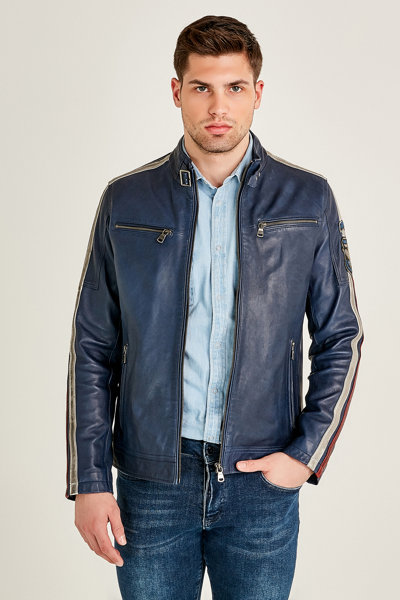
- Daytona Cafe Leather Racer Jacket for Men
In Blue Signature Sheepskin Leather
This Dark Blue Racer Jacket for men is a modern fit that accentuates and flatters your body. The jacket features straight, smooth lines, with a shorter length, hitting just to the top of the hips. The combination of blue sheepskin leather, with appliqued red and off-white colored stripes, makes it a stylish, yet comfortable jacket for everyday wear.

- Two zip pockets at chest
- Two side zip pockets
- Centre front zip closure
- High collar with snap stud latch
- Long sleeves with appliqued stripes
- Viscose lining
- US Naval Aviation Emblem on the left sleeve

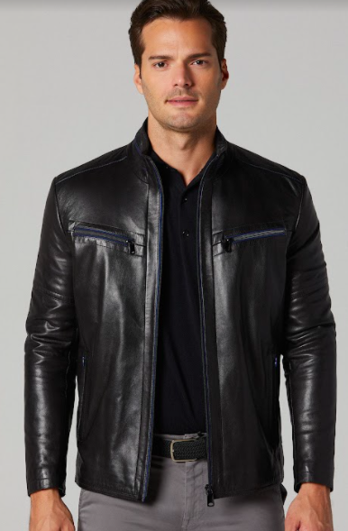
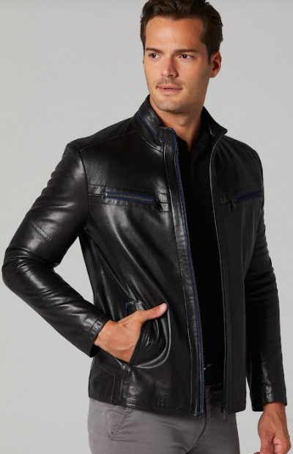
- Classic Café Leather Racer Jacket for Men
In Black Classic Sheepskin Leather
The Classic Black Racer jacket for men is a modern fit that goes a long way in ensuring that it looks like it was made for you. This racer jacket offers exceptional value for money, with a classic timeless design that will never go out of style.
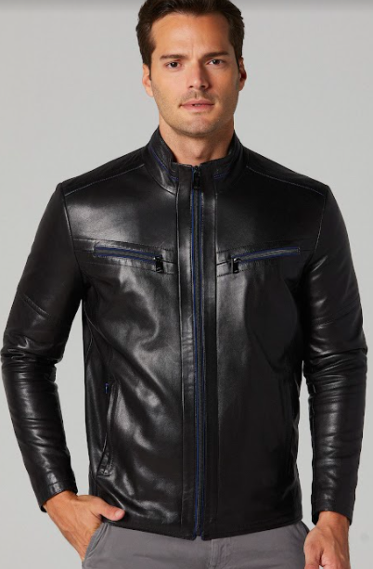
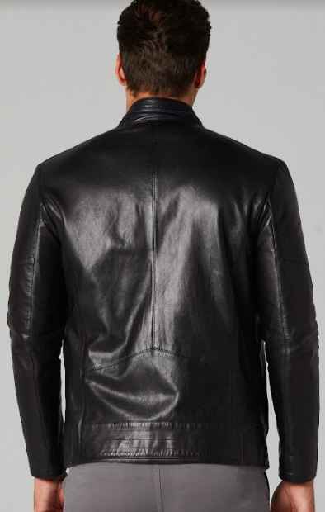
- Two zip pockets at chest
- Two side zip pockets
- Centre zip closure
- High banded collar
- Straight long sleeves
- Stitching pattern on the back
- Viscose lining
- Blue piping around collar, chest pockets and centre zip

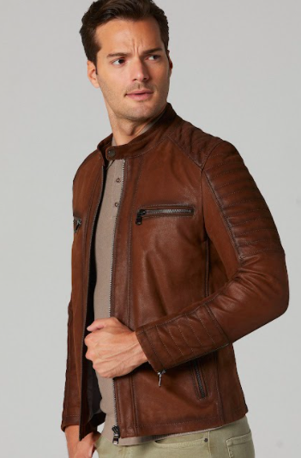
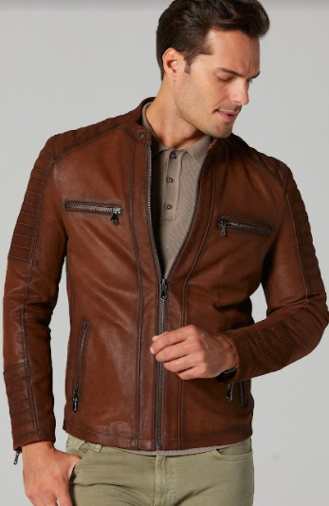
- Vintage Brown Cafe Leather Racer Jacket for Men
In Quilted Brown Sheepskin Leather

This is a classy vintage piece that needs to be added to your wardrobe. With the quilted details on the shoulders and sleeves of this brown leather jacket, you can enjoy your winter in a good manner. It is one of our signature designs, comprised of stitching patterns and quilted properties that reflect a traditional look of a genuine leather jacket.
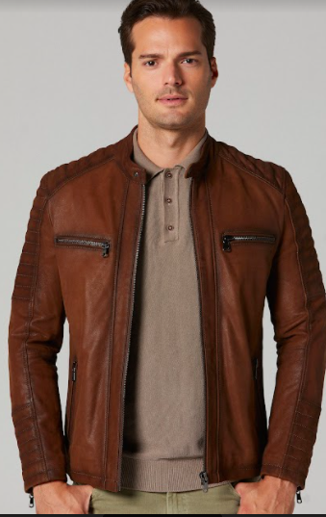
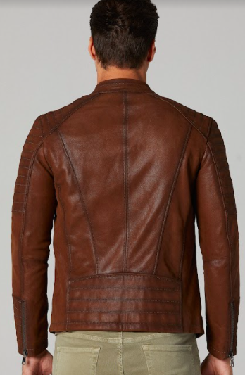
- Two zip pockets at chest
- Two side zip pockets
- Centre zip closure
- High collar with buttoned closure
- Full sleeves with zippered cuff
- Stitching pattern on the back
- Viscose lining
- Quilted shoulders and sleeves

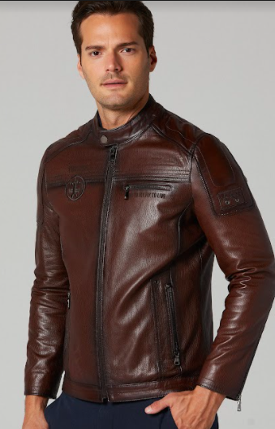
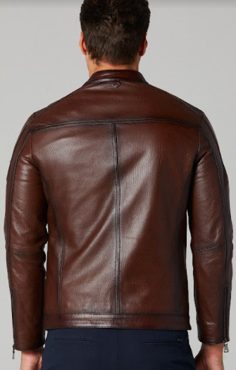
- Top Gun Motorcycle Leather Jacket For Men
In Dark Brown Signature Sheepskin Leather

This dark brown Cafe Racer Motorcycle jacket represents a unique vibe and personality, with its laser etched writing and logo patch work featured in the front. With a combination of style, durability and functionality, this leather jacket ensures protection and safety to all men, from inclement weather and accidents if you go down.

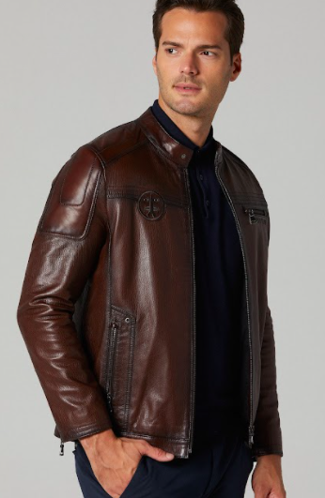
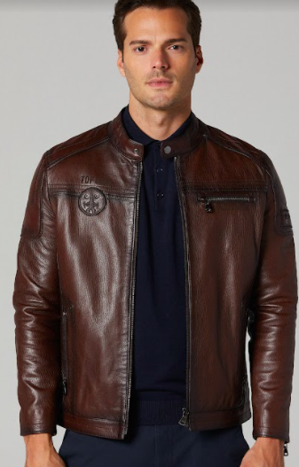
- Single chest pocket on the left
- Two side zip pockets
- Centre zip closure
- Racer style snap collar
- Full sleeves with zippered cuff
- Stitching pattern on the back
- Laser etched writing on the left chest side
- Viscose lining
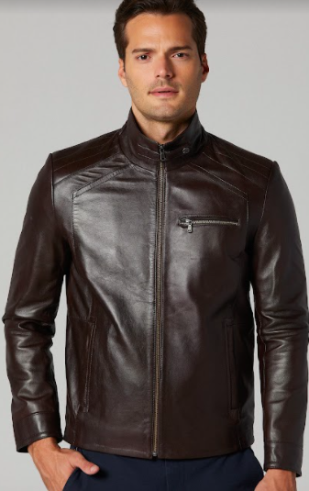
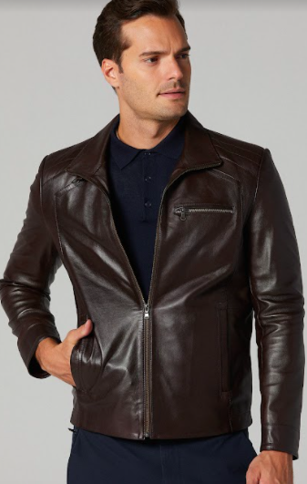
- Embroidered logo patch on the right chest side
- Sleek Cafe Leather Racer Jacket for Men
In Dark Brown Signature Sheepskin Leather

This sleek fit dark brown leather jacket for men stands out for its simplicity. The stitching details, straight lines and slim fit gives this jacket a versatile look, which allows you to dress it up or down, depending on your mood and occasion.
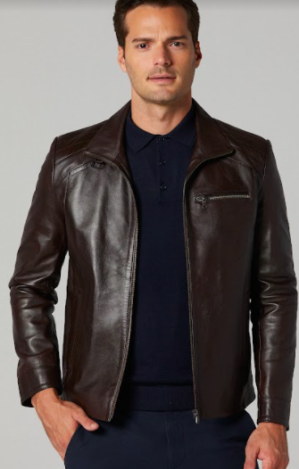
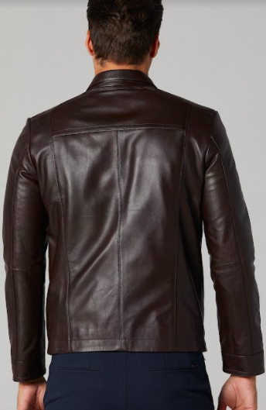
- Single chest pocket on the left
- Two open side pockets
- Centre zip closure
- High banded collar with snap button
- Straight long sleeves
- Viscose lining
- Stitching pattern on shoulders and back

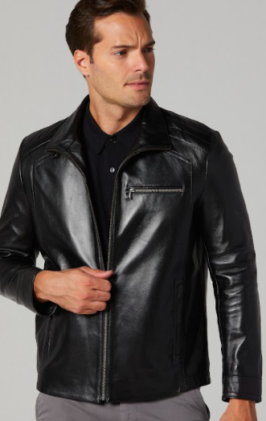
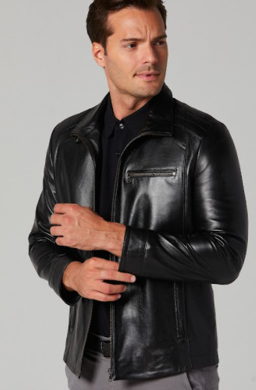
- Sleek Cafe Leather Racer Jacket for Men
In Black Signature Sheepskin Leather

This sleek fit black leather jacket for men stands out for its simplicity. The stitching details, straight lines and slim fit gives this jacket a versatile look, which allows you to dress it up or down, depending on your mood and occasion.

- Single chest pocket on the left
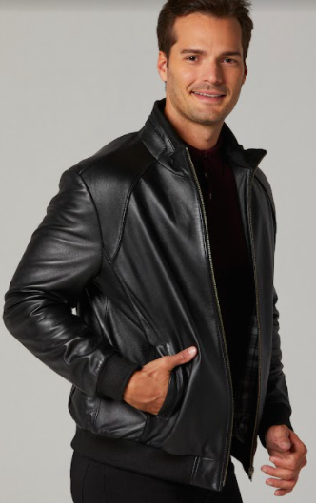
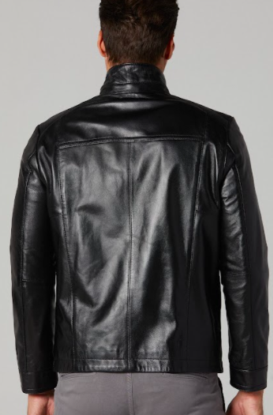
- Two open side pockets
- Centre zip closure
- High banded collar with snap button
- Straight long sleeves
- Viscose lining
- Stitching pattern on shoulders and back

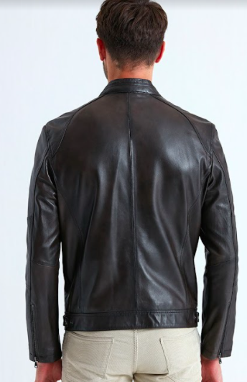
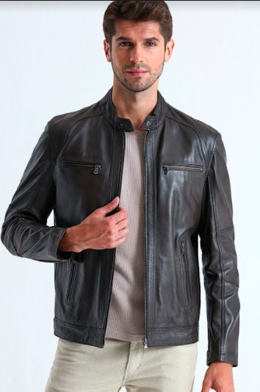
- Austin Cafe Leather Racer Jacket for Men
In Black Signature Sheepskin Leather
This black leather jacket for men is exactly what you need to stay on top of your game. Perfectly stitched and designed in high quality sheepskin leather, it features different properties with zipper pockets, centre zip closure and high collar. An ideal piece for avid riders as well as casual lovers of leather jackets.
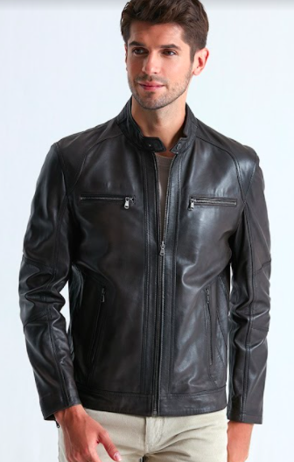
- Two zip pockets at chest
- Two side zip pockets
- Centre zip closure
- High collar with buttoned closure
- Full sleeves with zippered cuff
- Viscose lining
- Stitching pattern on sleeves and back

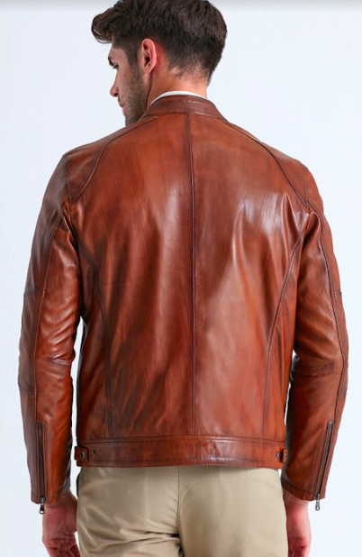
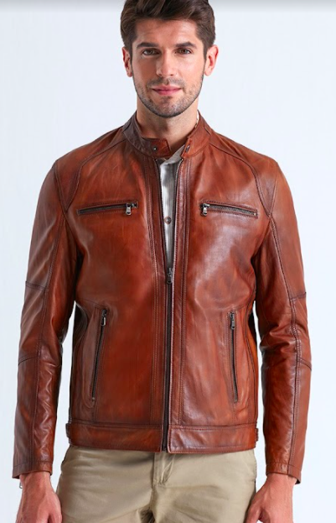
- Austin Cafe Leather Racer Jacket for Men
In Brown Signature Sheepskin Leather
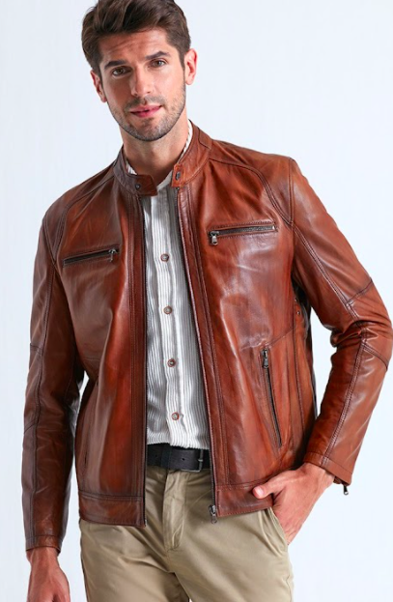
This brown leather jacket for men is exactly what you need to stay on top of your game. Perfectly stitched and designed in high quality sheepskin leather, it features different properties with zipper pockets, centre zip closure and a high collar. An ideal piece for avid riders as well as casual lovers of leather jackets.
- Two zip pockets at chest
- Two side zip pockets
- Centre zip closure
- High collar with buttoned closure
- Full sleeves with zippered cuff
- Viscose lining
- Stitching pattern on sleeves and back

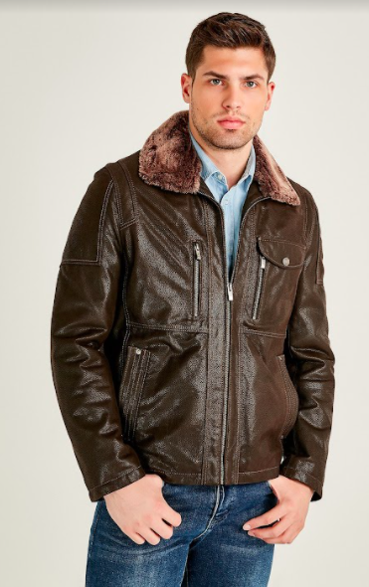
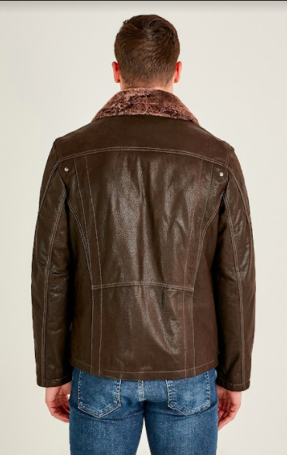
- Distressed Leather Jacket with Fur Collar for Men
In Dark Brown Sheepskin Leather
Made with genuine sheepskin leather, this vintage, slightly distressed dark brown jacket gives a classic 90s touch. The fur collar and the patch pocket will instantly put you in the limelight as you step out, while also providing you with immense comfort and warmth in the winter.
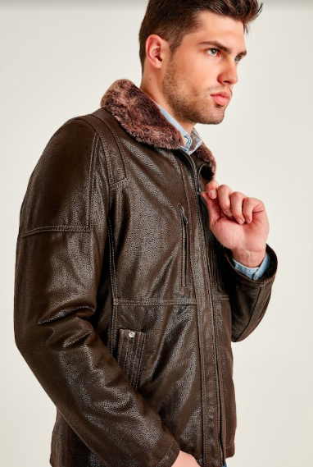
- Two vertical zip pockets at chest
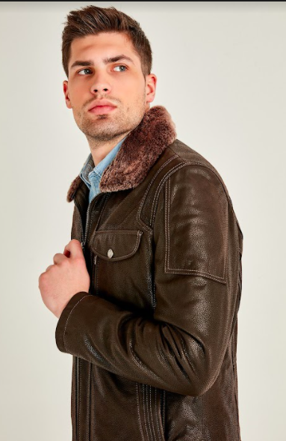
- One patch pocket on the left
- Two open side pockets
- Centre zip closure
- Shirt style fur collar
- Full sleeves
- Stitching pattern on the sleeves and back
- Viscose lining
- Dark brown distressed finishing

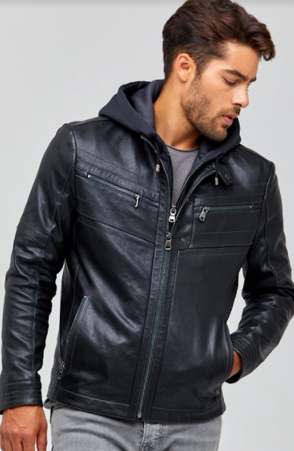
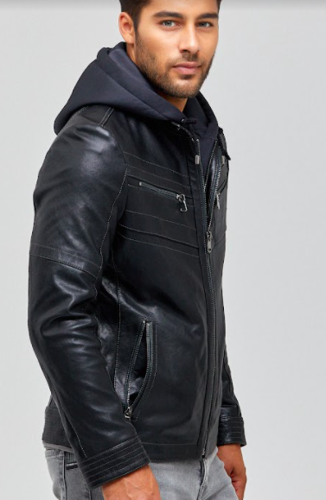
- Hooded Biker Leather Jacket for Men
In Blue Sheepskin Leather
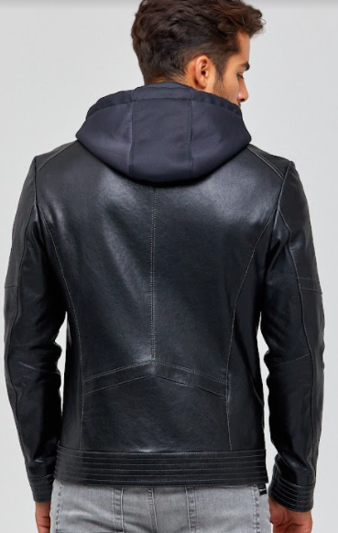
Layer up in this men’s hooded leather jacket that will keep you warm with its viscose lining and genuine sheepskin leather material. This biker style blue jacket equipped with a detachable hood inside and a zip-up option makes it an extremely practical design for all men who choose to wear it however they prefer.
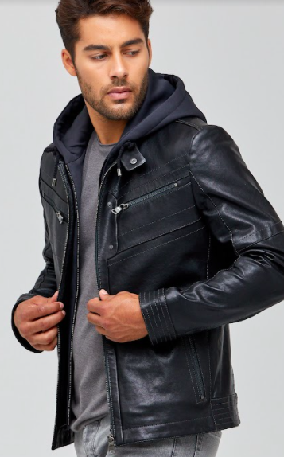
- Two zip pockets at chest
- Two side zip pockets
- Centre zip closure
- Removable hood, draw string, with zip closure inside
- Full sleeves
- Viscose lining
- Stitching pattern on chest, cuffs and back

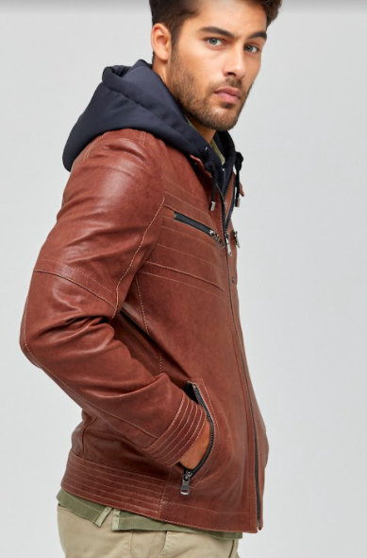
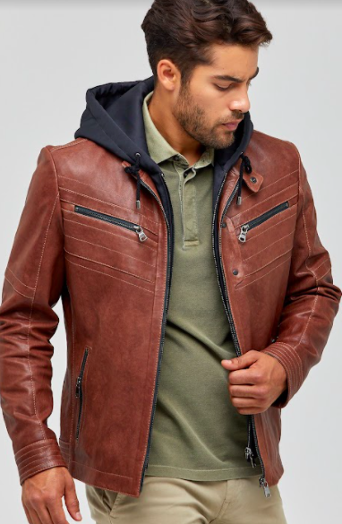
- Hooded Biker Leather Jacket for Men
In Brown Sheepskin Leather
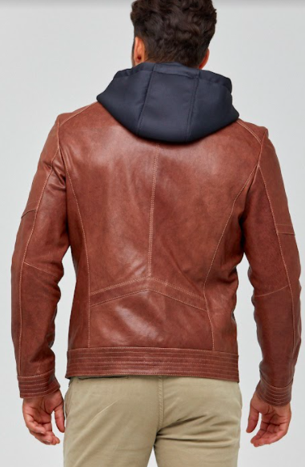
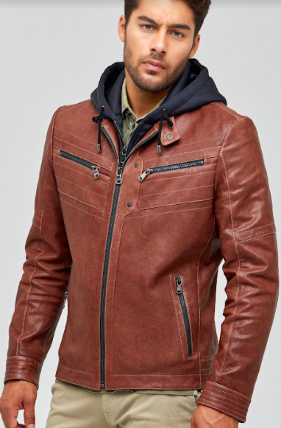
Layer up in this men’s hooded leather jacket that will keep you warm with its viscose lining and genuine sheepskin leather material. This biker style brown jacket equipped with a detachable hood inside and a zip-up option makes it an extremely practical design for all men who choose to wear it however they prefer.
- Two zip pockets at chest
- Two side zip pockets
- Centre zip closure
- Removable hood, draw string, with zip closure inside
- Full sleeves
- Viscose lining
- Stitching pattern on chest, cuffs and back

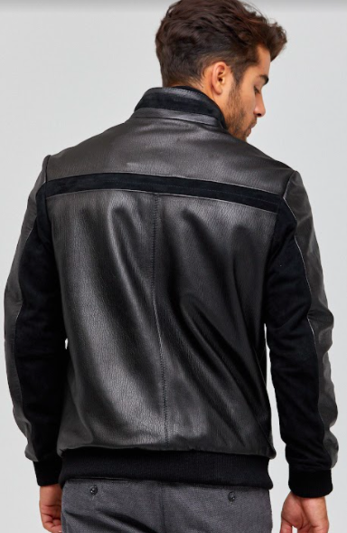
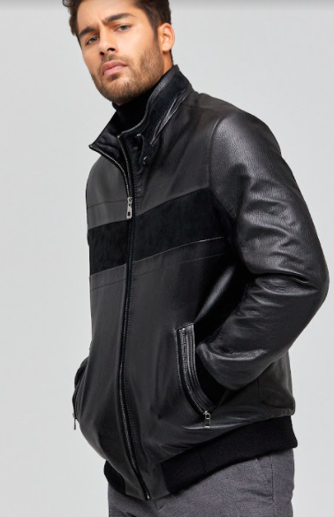
- Suede Leather Bomber Jacket for Men
In Black Signature Sheepskin Leather
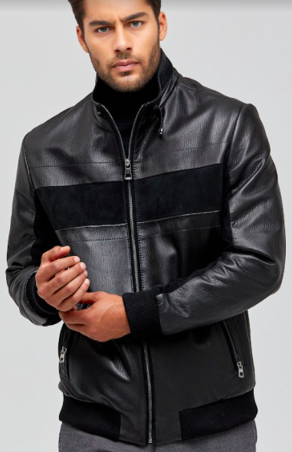
This black leather bomber jacket, finely constructed from genuine leather is a must have in every man’s wardrobe. With a touch of suede and the jacket’s classic design, you can perfectly pair it with your favorite jeans to instantly transform into the star player of any look you desire.
- Two side zip pockets
- Centre zip closure
- Full sleeves
- High collar with buttoned closure
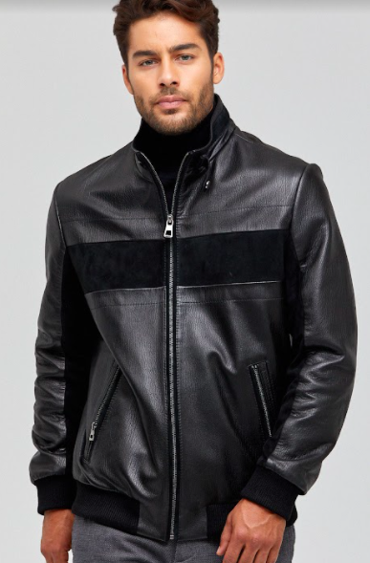
- Rib knit cuffs style
- Viscose lining
- Suede leather patch in front, back and sleeves
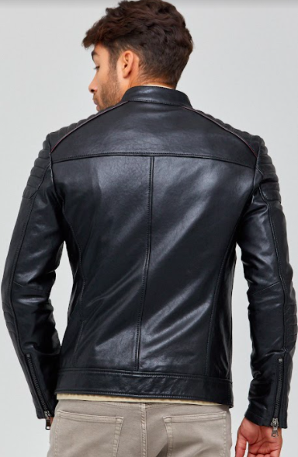
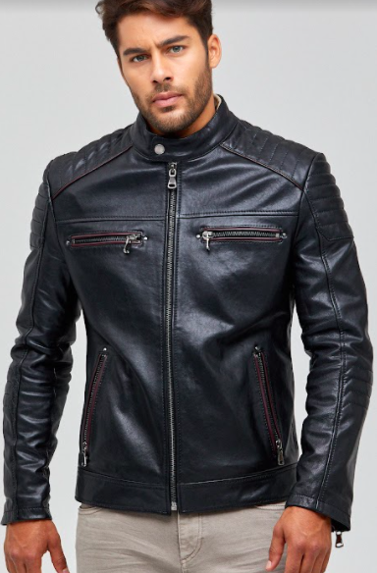
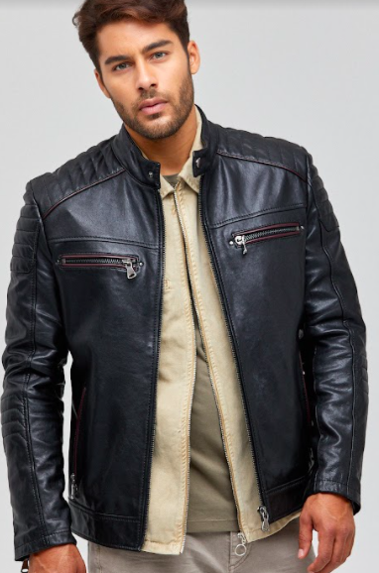
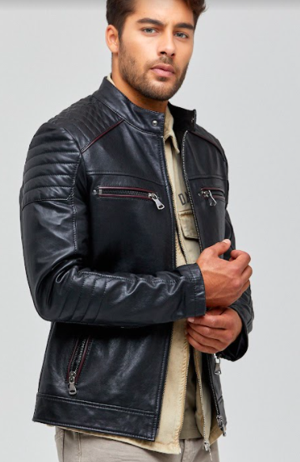
- Vermont Quilted Cafe Leather Racer Jacket for Men
In Black Signature Sheepskin Leather
This cafe leather jacket for men is an impeccable design, which is bound to give you a biker character. The quilted shoulders and sleeves, along with its maroon colored piping are some enticing properties of this leather jacket that will certainly steal the show everywhere you go.

- Two zip pockets at chest
- Two side zip pockets
- High collar with buttoned closure
- Centre zip closure
- Full sleeves with zippered cuff
- Quilted shoulders and sleeves
- Viscose lining
- Maroon piping around pockets and quilted shoulders
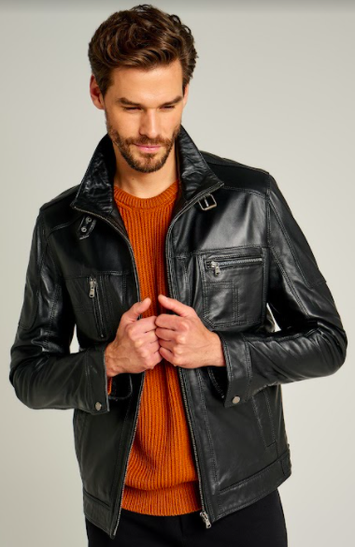
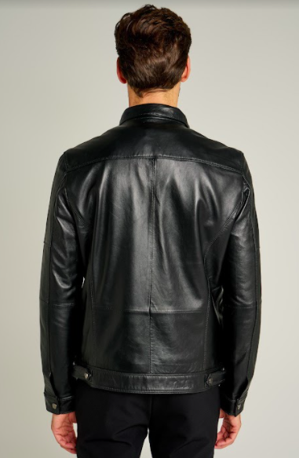
- Premium Leather Field Jacket for Men
In Black Signature Sheepskin Leather
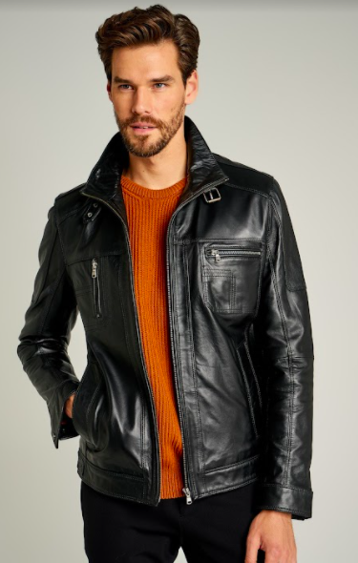
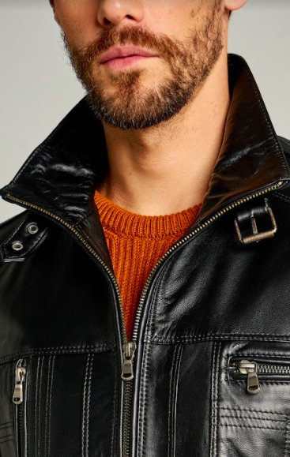
This genuine leather field jacket gives off a serious fashion statement vibe, as it is considered a classic and top notch premium piece in every man’s wardrobe. With fashion trends evolving and changing all the time, a good black leather field jacket is a timeless masterpiece that will never go out of style!
- One vertical chest zip pocket
- One horizontal chest zip pocket
- Two open side pockets
- High collar with snap stud latch
- Centre zip closure
- Full sleeves with button cuffs
- Adjustable side tabs with snap button
- Viscose lining
- Stitching pattern on chest pockets

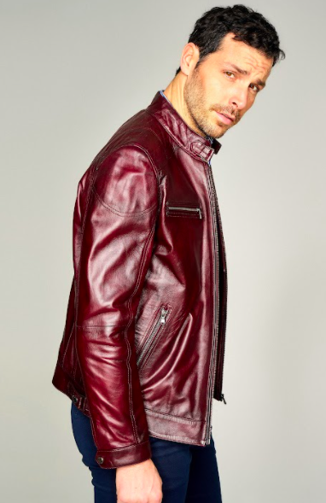
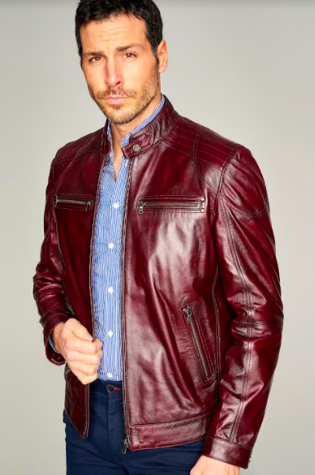
- Phoenix Cafe Leather Racer Jacket for Men
In Dark Red Sheepskin Leather
This alluring dark red leather jacket will catch every glimpse as you walk past a crowd. With its simplistic design of a standard cafe racer jacket, stitched in our signature dark red sheepskin leather, it instantly becomes a stylish statement jacket that all men must own.
- Two zip pockets at chest
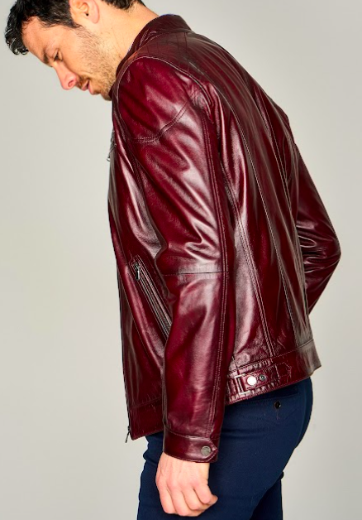
- Two side zip pockets
- High collar with buttoned closure
- Centre zip closure
- Full sleeves with button cuffs
- Viscose lining
- Stitching pattern on shoulders
- Dark red sheepskin leather

